Hotel Accommodation form for

机器学习暑期学校 ( Machine Learning Summer School）
1. Name:
2. E-mail address:
3. Category
Hotel | Room type | RoomRate(RMB)  One breakfast | Check-in date | Check-out date
Standard room in Building 2 ( 4 star) | Twin or double | 450
Standard room in Building 4 ( 4 star) | Twin or double | 500

- This rate includes service charge and one breakfast. The extra breakfast is RMB50 per day.
- Please send this form back to smd@bjfriendshiphotel.com to make the booking.
- The booking dead line is on June 10th

Many thanks for your reservation.

Helen Yu
Beijing Friendship Hotel
Tel: 86-10-68498080
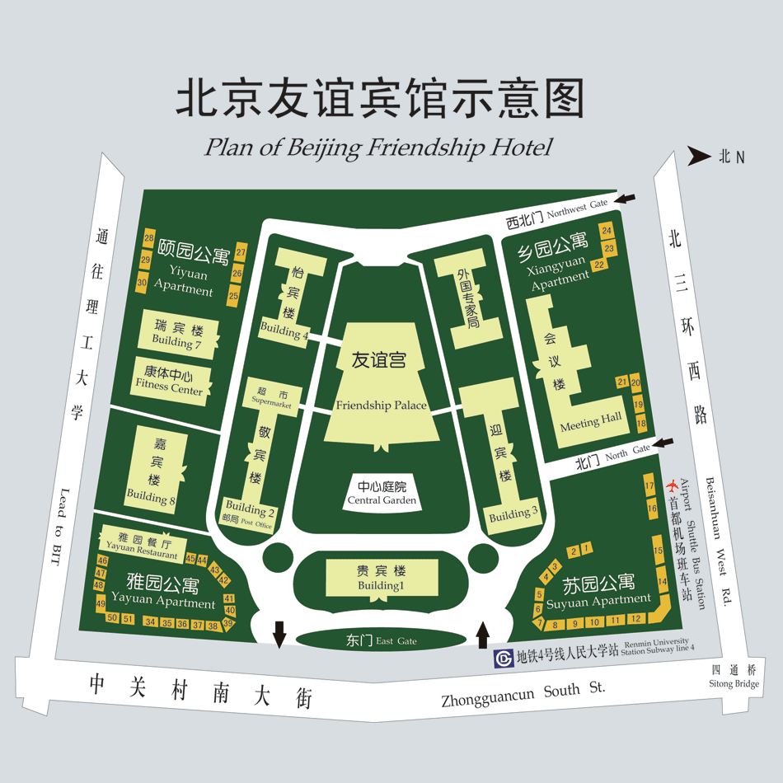
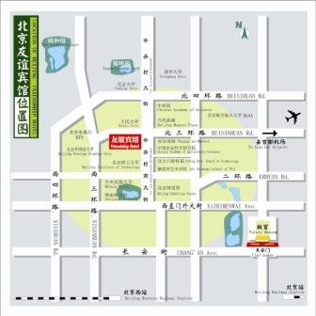
Moble Phone:15810493609

